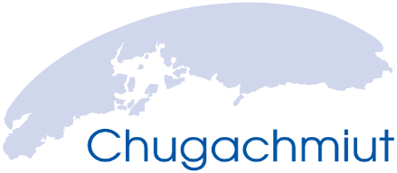 WOMEN'S GENERATIONAL HEALING
“Bringing Grandmothers, Mothers, and Daughters Together”
April 20 – 24, 2020 @ Alyeska Resort in Girdwood, Alaska

PARTICIPANT INFORMATION
Name __________________________________________________________________________
Tribal Affiliation(s) (if applicable) _____________________________________________________
Organization/School/Tribe Representing _______________________________________________
City _________________________________________ State ____________ Zip Code __________
Telephone ( ) _________________________ Date of Birth: _____________________________
Email Address ____________________________________________________________________
Conference Logistics: This conference is provided free of charge for 3 family members(1 grandmother, 1 mother, 1 daughter) (12 and older) women from each community and currently living in the communities of Nanwalek, Port Graham, Tatitlek, Chenega Bay, Valdez, Seward and Eyak. Participants that are approved will be on a first come basis. No alcohol or drugs allowed as this is a sober event. Please fill out the information below and return to DanielleL@Chugacmiut.org
Conference Location: Alyeska Resort in Girdwood Alaska. If more participants want to attend but have their own lodging source, please indicate below. Also, all guests will be sharing a room, if there is a guest attending you would like to room with we will do our best to accommodate. Travel, Lodging, and Meals provided by Chugachmiut. Contact Danielle Larsgaard at (907) 562-4155 or (800) 793-2891 if you have questions, comments or need additional information.
Lodging Information: Please do not bring any other family members than listed in group, as this is a shared living space during the conference.)
[ ] I’ll share with anyone. [ ] I’ll share a room with (name(s) ______________________________________________
[ ] I would like to attend the conference, I have my own lodging in Anchorage, I am in Anchorage already for another reason (Details): __________________________________________________________________________
Travel Information:
[ ] I am requesting transportation from the community of [ ] Nanwalek [ ] Port Graham [ ] Tatitlek [ ] Seward [ ] Chenega Bay [ ] Valdez [ ] Cordova Note: _______________________________________________________________
[ ] I will be in Anchorage anyway, I don’t need airfare

